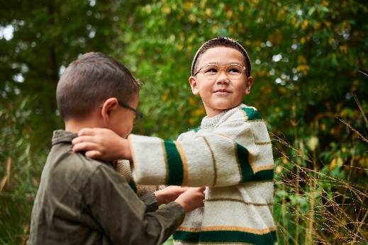 | Autumn adventures are better together 🍂  Crunching leaves, chasing through the woods, jumping in puddles. Every laugh and every splash becomes a memory to keep.  Just like our Milo & Me frames: designed to mix, match, and share joy in every season.  Warm tones. Playful spirit. Ready for every game outside. 💛  #MiloAndMe #AutumnAdventures #BetterTogether #KidsStyle #FamilyMoments
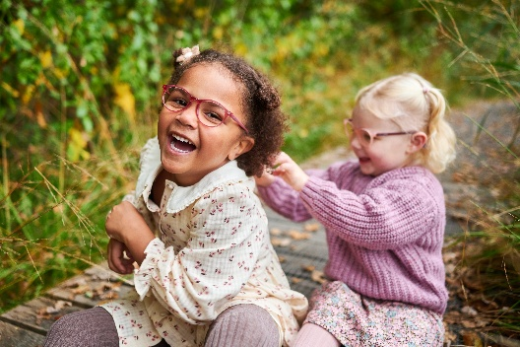 | There’s something magical about autumn: the laughter echoing between the trees, the golden light, the smell of rain and leaves.  It’s even better when shared.  Milo & Me frames are made for moments like these!  #MiloAndMe #AutumnVibes #TogetherIsBetter #KidsEyewear #FallFun
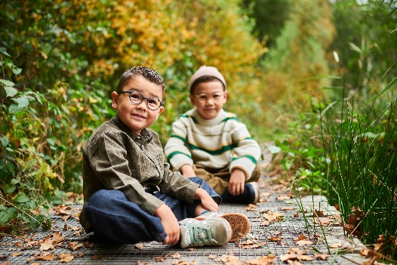 | Crunching leaves. Jumping in puddles. Chasing smiles.  Autumn is better together 🍁  #AutumnAdventures #MiloAndMe
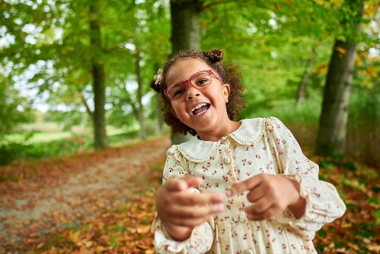 | Milo & Me, playful by nature and designed for every season.  #MiloAndMe #KidsFashion #AutumnStyle #BetterTogether
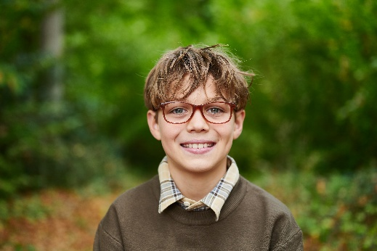 | Check out our cozy autumn tones that pair perfectly with every adventure outside. 🍂  #MiloAndMe #KidsFashion #AutumnStyle #BetterTogether
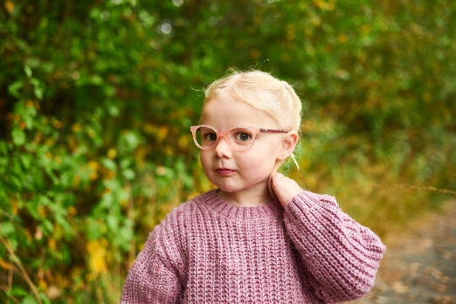 | Every season brings new adventures, and Milo & Me frames are there for every single one.  Strong, flexible, and made for carefree play.  Because nothing should stop a child from exploring. 🍂  #MiloAndMe #AutumnAdventures #BetterTogether #KidsEyewear #PlayOutside
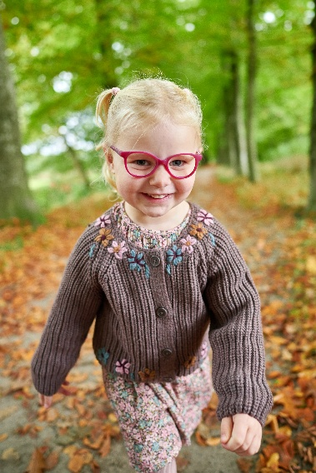 | Jump in puddles, climb the biggest tree, chase the sunlight through the leaves. Your glasses can keep up! 🌤️  #MiloAndMe #KidsEyewear #OutdoorPlay #AutumnFun #MadeForAdventure

